**Assignment: Display Date**

Your project manager needs you to make two templates for her front-end team: one to display the current date, and one to display the current time. Use the JSTL library to format the date so the front end developers can edit easily!

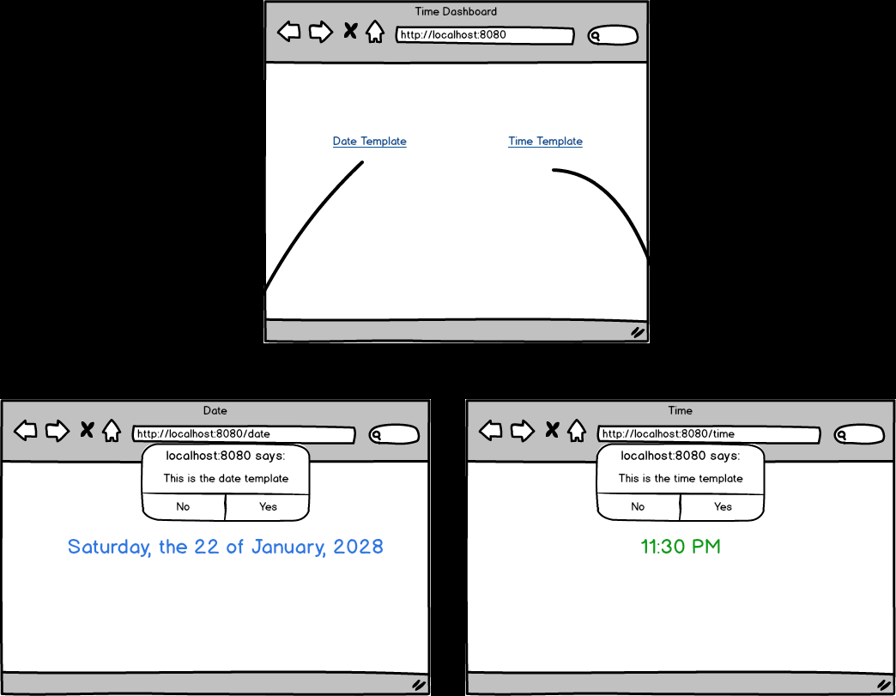

Topics:

* Passing Data
* Routing
* Time formatting

Tasks:

* Use new java.util.Date() in your controller to get the date.
* Create an app that will render three pages.
* Render one home page as the dashboard with links to the two others.
* Render one page at /date with the current date formatted as Saturday, the 22 of January, 2028
* Link an **external** **javascript** file to the /date template that **alerts** "This is the date template".
* Link an **external** **css** file to the /date template that **colors** the date in blue.
* Render one page at /time with the current time formatted as 11:30 PM
* Link a **external** **javascript** file to the /time template that **alerts** "This is the time template".
* Link a **external** **css** file to the /time template that that **colors** the time in green.